**Program:**

Inserting data:

/*

 * To change this license header, choose License Headers in Project Properties.

 * To change this template file, choose Tools | Templates

 * and open the template in the editor.

 */

package javaapplication2;

import com.mongodb.client.MongoCollection;

import com.mongodb.client.MongoDatabase;

import org.bson.Document;

import com.mongodb.MongoClient;

import com.mongodb.MongoCredential;

public class mongo_class {

      public static void main( String args[] ) {

      // Creating a Mongo client

      MongoClient mongo = new MongoClient( "localhost" , 27017 );

      // Creating Credentials

      MongoCredential credential;

      credential = MongoCredential.createCredential("sampleUser", "student",

         "password".toCharArray());

      System.out.println("Connected to the database successfully");

      // Accessing the database

      MongoDatabase database = mongo.getDatabase("student");

      /* Retrieving a collection*/

      MongoCollection<Document> collection = database.getCollection("department");

      System.out.println("Collection department selected successfully");

      Document document = new Document("title", "MongoDB")

      .append("id", 1)

      .append("description", "department")

      .append("code", "IT")

      .append("name", "Information Technology");

      collection.insertOne(document);

      System.out.println("Document inserted successfully");

   } }

Retrieving data:

/*

 * To change this license header, choose License Headers in Project Properties.

 * To change this template file, choose Tools | Templates

 * and open the template in the editor.

 */

package javaapplication2;

/**

 *

 * @author Admin

 */

import com.mongodb.client.FindIterable;

import com.mongodb.client.MongoCollection;

import com.mongodb.client.MongoDatabase;

import java.util.Iterator;

import org.bson.Document;

import com.mongodb.MongoClient;

import com.mongodb.MongoCredential;

public class Retriveall {

   public static void main( String args[] ) {

       // Creating a Mongo client

      MongoClient mongo = new MongoClient( "localhost" , 27017 );

      // Creating Credentials

      MongoCredential credential;

      credential = MongoCredential.createCredential("sampleUser", "student",

         "password".toCharArray());

      System.out.println("Connected to the database successfully");

      // Accessing the database

      MongoDatabase database = mongo.getDatabase("student");

      // Retrieving a collection

      MongoCollection<Document> collection = database.getCollection("department");

      System.out.println("Collection sampleCollection selected successfully");

      // Getting the iterable object

      FindIterable<Document> iterDoc = collection.find();

      int i = 1;

      // Getting the iterator

      Iterator it = iterDoc.iterator();

 while (it.hasNext()) {

         System.out.println(it.next());

      i++;

      }

   }

}

**Screenshots:**

Inserting data:

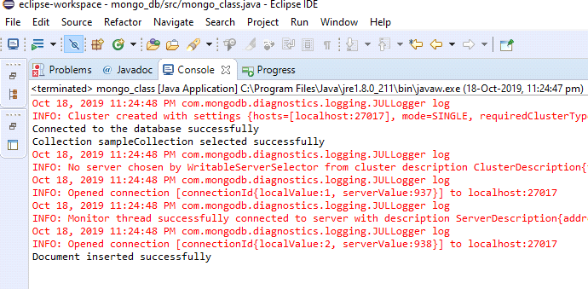

Retrieving data:

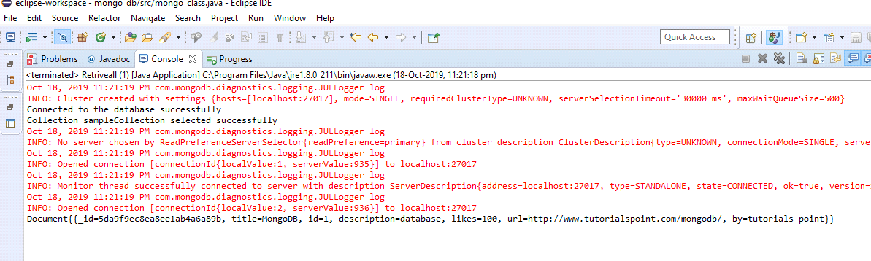

MongoDB Database:

